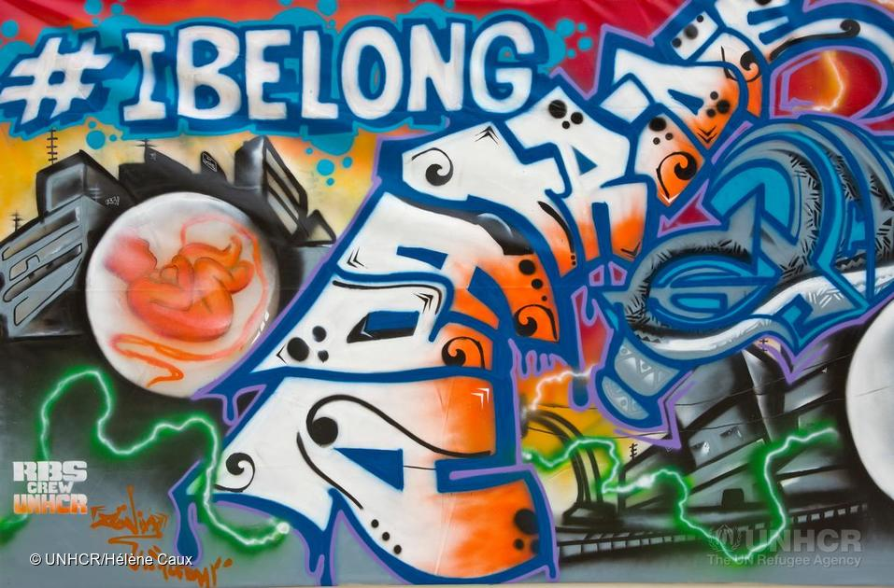
Refugee & Race Equality Informal Education Resource

2016 Edition
Greetings from JCORE!
JCORE is the Jewish Council for Racial Equality.
Our work focuses on a number of key areas:
- Promoting Black-Asian-Jewish dialogue
- Achieving justice for refugees and asylum seekers
- Educating the Jewish community on issues of race and asylum.
It is that last point that compelled us to create this document. This is a resource for you to use as and when you see fit. It contains ready-made sessions and a number of ideas for you to build your own.

If you have any questions, would like some more information or would like to get involved in the work JCORE does, please email us at admin@jcore.org.uk or give us a call on 0208 455 0896. We’d also love your feedback about this resource, so get in touch to let us know what worked well and what wasn’t so successful.

We believe that a concern for social justice should be an integral part of our identity and our relationship with the rest of society.....
.....that we need to speak out against racism and speak up for asylum seekers and refugees because, as Jews, we know what happens when others stand by and do nothing.....
.....and that by educating ourselves and engaging with these issues we can tackle racism and help those who are trying to find safety in the UK.
Contents
Asylum Seekers and Refugees 4
Asylum Seekers in the UK 6
Race Equality 7
Race Equality in the UK 8
A Jewish Response 9
Refuge & Asylum 9
Racial Equality 10
Build Your Own Session 11
Microwave Sessions (Ready Made) 14
Jewish Heroes of Human Rights 14
Who is a refugee? 24
Journey to WALL-E’S World 31
The Dot Game 38
The Tikkun Olam Court 40
The Bible – a tale of immigration and asylum 42
Feedback 54

Asylum Seekers and Refugees
Refugee: “A person who owing to a well-founded fear of being persecuted for reasons of race, religion, nationality, membership of a particular social group or political opinion, is outside the country of his nationality and is unable or, owing to such fear, is unwilling to avail himself of the protection of that country; or who, not having a nationality and being outside the country of his former habitual residence as a result of such events, is unable or, owing to such fear, is unwilling to return to it.”
The 1951 United Nations Convention Relating to the Status of Refugees
Asylum Seeker: A person who has left their country of origin and formally applied for asylum in another country but whose application has not yet been concluded.
Refused Asylum Seeker: A person whose asylum application has been unsuccessful and who has no other claim for protection, awaiting a decision. Some refused asylum seekers voluntarily return home, others are forcibly returned and for some it is not safe or practical for them to return until conditions in their country change.
Unaccompanied Asylum Seeking Child: A child (under 18) who is outside of their country of origin, seeking asylum, without parents, relatives or a legal guardian.
Trafficked Individual: An individual who is taken away from their homes (by force, coercion, abduction, fraud, deception, or abuse of power), to another area for the purpose of exploitation. Exploitation can happen in many ways, such as through prostitution or other forms of sexual exploitation, forced labour or services, slavery or practices similar to slavery, servitude or the removal of organs.

By the end of 2015, 65.3 million individuals were forcibly displaced worldwide as a result of persecution, conflict, generalised violence, or human rights violations. Of these, 21.3 million were refugees, 40.8 million internally displaced person and 3.2 million asylum seekers.
- Syria (over 4.9 million)
- Afghanistan (2.7 million)
- Somalia (1.1 million) Countries where most of the
- South Sudan (778,700) world’s refugees come from - 2015
- Sudan (628,800)

- The top three countries on this list make up 54% of all refugees.
- Children below 18 years of age constituted 51% of the refugee population in 2015.

- Turkey (2.5 million)
- Pakistan (1.6 million)
- Lebanon (1.1 million) Countries which host the
- Iran (979,400) most refugees worldwide - 2015
- Ethiopia (736,100)

- In Lebanon, one in five people is a Syrian refugee.
- In 2011 Turkey was 59th on the list of host countries for refugees.
- The top 10 refugee-hosting countries combined host 58% of all refugees.

- Germany (441,900)
- USA (172,700)
- Sweden (156,400) Countries which received the
- Russia (152,500) most new asylum applications - 2015
- Turkey (133,300)

United Kingdom (38,878)
- 98,400 unaccompanied or separated children lodged asylum applications in 2015. The highest number on record since the UNHCR started collecting such data in 2006.
Asylum Seekers in the UK
- Around 40% of asylum applications in the UK are successful (with 60% initial decisions refused).
- Over a third of asylum applications that are unsuccessful but appealed are overturned.
- Last year, over 3,000 unaccompanied children applied for asylum in the UK. Unaccompanied minors are far less likely to be granted long term protection than adults seeking asylum.
- Most unaccompanied minors are given short term leave, which allows them to stay in the UK for 2.5 years or until they are 18, after which time they must re-apply for an extension.
- The majority of asylum seekers do not have the right to work in the United Kingdom and so must rely on state support.
- Housing is provided, but asylum seekers cannot choose where it is, and it is often ‘hard to let’ properties which Council tenants do not want to live in.
- Cash support is available, and is currently set at £36.95 per person, per week, which makes it £5.28 a day for food, toiletries, travel, clothing and other necessities.
- Asylum seekers whose claims have been refused but are unable to return to their country of origin receive less than that and are more often than not left in destitution.
- Refugees, pending asylum cases, and stateless persons make up 0.19% of the UK population.
- Negative stereotypes propagated by politicians and the press lead to negative attitudes towards refugees and asylum seekers among much of the British population.

Race Equality
Racism describes a complex set of attitudes and behaviour towards people from another racial or ethnic group, most commonly based on:
- the belief that differences in physical/cultural characteristics (such as skin colour, language, dress, religious practices, etc.) correspond directly to differences in personality, intelligence or ability, leading to assumptions about mental superiority and inferiority;
- the social or economic power of members of one racial or ethnic group to promote, enforce or ‘act out’ such attitudes. Racist views and attitudes usually lead to discriminatory behaviour and practices that in turn contribute to inequality and social exclusion.
Stereotyping involves labelling or categorising particular groups of people according to preconceived ideas or broad generalisations about them – and then assuming that all members of that group will think and behave identically.

Race Equality in the UK
Race equality in the UK has improved greatly over the past sixty years, however there are still a huge number of problems with the treatment of minorities in the UK.
- The 2015 general election produced the most diverse House of Commons yet, with 42 minority-ethnic MPs, up from 27 in 2010. This is still only 6.6% of the total number of MPs however whilst 18% of the UK population comes from a non-white background.
- Similarly, two-thirds of the companies in the FTSE 100 have no full-time executives from minority groups at board level.
- A report by Runnymede, a race equality think-tank, found black and minority ethnic students had to do better than their white peers in order to get into university. Those with the same A-Level results as other students were also less likely to be offered a place at the more prestigious institutions.
- The report also found that 0.49% (85) of professors in UK academia are black, in comparison to 92.4% (15,905) who are white. Of those 85, just 17 are women.
- 25% of professional football players in England are black; however based on current figures, about 6.5% of managers in the top four division of English football are black. A 2015 study also found that of 552 key coaching jobs in English football, only 19 were occupied by people from black and minority ethnic backgrounds.
- Black people are seven times more likely to be stopped by police using stop-and-search than white people, however only about one-in-ten of those stops lead to an arrest.
- 21% of black children felt their skin colour would make it harder to succeed in the future, compared to 2% of white children and 13% of Asian origin. (BBC research poll).
- In 2014/15, 52,528 hate crimes were recorded by the police, of which 82% were race hate crimes; 11% were sexual orientation hate crimes; 6% were religion hate crimes; 5% were disability hate crimes; and 1% were transgender hate crimes. (It is possible for one hate crime offence to have more than one motivating factor which is why the above numbers sum to more than 100 per cent).

A Jewish Response
“Justice, justice shall you pursue.”
Deuteronomy 16:20

Refuge & Asylum
“You shall not oppress a stranger, for you know the feelings of the stranger, having yourselves been strangers in the land of Egypt.”
Exodus 23:9
“If a stranger lives with you in your land, do not ill treat that stranger. The stranger living with you must be treated as one of your own, and you shall love the stranger as yourself, for you were strangers in the land of Egypt: I am the Eternal One your God.”
Leviticus 19:33
“When you gather grapes in your vineyard, do not pick it over again; that which is left shall go to the stranger, the fatherless, and the widow. Remember that you were slaves in the land of Egypt; therefore I command you to do this thing.”
Deuteronomy 24:21

‘It is easy to love our neighbour. It is difficult to love the stranger. This is why the Torah commands us only once to love our neighbour, but on thirty-six occasions commands us to love the stranger. A neighbour is one we love because he is like us. A stranger is one we are taught to love precisely because he is not like us. That is the Torah’s repeated and most powerful command. I believe it to be the greatest religious truth articulated in the past four thousand years.’
Rabbi Jonathan Sacks
‘This commandment, to love the stranger is repeated throughout the Torah 36 times.
‘The migration of people across the globe on a scale never before witnessed in human history has made that commandment one of the most relevant to our present society, and one of the most urgent the Torah gives us. It brings back to our attention the two reasons given for it: the divine authority, I am the Eternal your God – your God and his God, but also “for you were strangers in the land of Egypt.” That reminder runs as a refrain throughout the law making of the Torah, throughout the Tanach and rabbinic literature.
‘For it is the basis of all Jewish morality. If you want to know what to do in any situation, just remember what it was like when YOU were in that situation.’
Rabbi Willy Wolff
‘It seems to me that true religion begins with the law about protecting and shielding the alien and the stranger. It’s there in practically every religious tradition and it is there that men and women discover the idea of humanity. contd.
‘Voltaire said that if we believe in absurdities we shall commit atrocities. If we believe in the absurdity that people who are fleeing their country, their home, their families, their job are doing it for a whim, we will be on the way to committing the atrocities. Nobody does that unless they have to.’
Rabbi Hugo Gryn

Racial Equality
You shall not stand idly by when your neighbour’s blood is being shed...thou shalt love thy neighbour as thyself.”
Leviticus 19:16-18
“Have not all of us one Father, has not one God created all of us?”
Malachi 2:10
“To me, O Israelites, you are just like the Ethiopians” declares the Eternal. “True, I brought Israel up from the land of Egypt, but also the Philistines from Capthor and the Arameans from Kir.”
Amos 9:7
‘What is hateful to you, do not do to your neighbour. That is the whole Torah, the rest is commentary, go and learn it.’
Hillel
“The hatred of other people destroys your own world.”
Pirke Avot 2:15
“Blessed are my people Egypt, and Assyria, my creation, and my inheritance, Israel.
Isaiah 19:23-25

‘People usually hate what they do not understand.’
Moses ibn Ezra
‘Basing myself on the Talmudic saying that if all repented the Messiah would come, I decided to do something about it. I was convinced I would be successful. But where to start? The world is so vast. I shall start with the country I know best, my own. But my country is so very large. I had better start with my own town. But my town too is so very large. I had better start with my street. No, my home. No, my family. Never mind, I shall start with myself... – So it is with racism.’
Rabbi Shmelke
Hostility blinds you to others’ virtues
Hostility makes an easy alliance with lies
Hostility comes from fear Ibn Gabirol

Build Your Own Session
Take any of these activities to create your own session addressing issues of race, stereotypes, asylum and refugees or “the other”.
Most of these activities engage with the idea of “the other” – separating groups, pitting groups against each other or isolating individuals – an idea that has been used throughout history to diminish the rights of certain groups. Other activities are more focused on a particular issue; some are very general and can be used for any number of issues.
Theatre of the Oppressed
- Mirror - in pairs – pairs must mirror each other. One has the leading hand, the other must copy.
- Stature – individual must mould someone’s stature to that of an authority figure. The rest of the group has to guess who it is.
- Secret Whispers – everybody sits in a circle – somebody whispers a statement to their neighbour which is then passed around the circle. The last person must say it aloud – see how much it has changed
- Mirror Line – everybody stands in a straight line – the person at the front does an action/movement/walk that gets passed down the line – everybody must copy the person in front of them. How much does it change at the back of the line/how far behind the front are they?
- Situation acting – a scene is enacted that goes completely wrong (e.g. someone says something racist and no-one reacts) – Scene is repeated. An audience member shouts freeze-frame at the point of action (e.g. where no-one reacts to the racist comment) to replace one of the other characters – what would they do differently?
As three activities
- Protector vs. enemy – everyone in a circle must choose one protector and one enemy and make sure that their protector is always between them and their enemy.

- Triangle protector vs. enemy – everyone in a circle must choose two people and make sure they are always the same distance away from both of them making a triangle.

- Connections – everyone in a circle must choose two people with whom they feel a connection and try stand as close to them as possible.

Which Stereotype am I?
- In pairs
- Each has a sticker on their head of a positive/negative stereotype
- General ones – e.g. smelly, uneducated, cheap, lazy, handsome, good at football/basketball
- Couple of positive ones, lot of negative ones
- Pairs have a regular conversation as themselves but your partner must see you and react to you according to your stereotype (Individuals don’t know what their own stereotype is).
Spectrum
- Two sides of a room – representing true/false or agree/disagree
- Statements or facts are read out and chanichim must decide which side of the room to stand on.
Where the wind blows
- In a circle – someone standing in the middle.
- Person in the middle says a statement.
- All those that agree must stand up and find a new seat, leaving a new person stuck in the middle.
The Lonely Penguin
- One person stands in the middle with a piece of paper between their knees (it can’t drop)
- Everyone else sits in a circle around them. There must be one empty seat.
- The penguin must sit down in the empty chair however those in the circle are working against them and can move places to sit in the empty chair.
Huggy Bears/Huggy Jellyfish/Outsiders
- Everyone walks around individually
- A number is shouted out
- People must congregate in groups of that number
- Depending on the number in the group/number called out, people are often left without a group
Minority vs. Majority
- Two groups (or more) – one big, one small – competing. The quickest group wins.
- Human Knot – everyone stands in a circle, shoulder to shoulder and shut their eyes. Everyone puts their hands in the middle and grab a hand. Everyone then opens their eyes and without breaking the link, must unravel themselves to form a regular circle.
- Boat in the Water – groups must stand on a sheet of paper and turn it over to stand on the other side without stepping off it.
- One Person-One Vote/Cup – Each group has a bucket of water and an empty bucket a short distance away. Each individual has a plastic cup. Teams must transport the water in the cups in their mouths from the water bucket to the empty bucket.
- Boat Over Troubled Water – Each group has one chair per person plus one extra and must use them to cross the sea. (Usually done caterpillar style).
- Stuck in the Mud – One group are the catchers. Only people from the same group can save those who have been stuck.
The Handshake
- Everyone walks around individually.
- Everyone must pair up and shake right hands with their partner.
- Everyone returns to walking.
- Everyone must pair up with someone new and high-five their new partner with their left hand.
- Everyone returns to walking.
- Everyone must pair up with someone new and do a foot-five/foot shake.
- Everyone returns to walking.
- Everyone must then return to their first partner and start shaking hands. While doing this they must find their second partner and high five. While shaking and high-fiving, they must then find their third partner and foot-shake.
The Lemon Game
- Everyone sits in a circle.
- In the middle are enough lemons for one each.
- Everyone takes a lemon and is given 5 minutes to study and examine it, really get to know it.
- They must then put them back in the middle and turn around whilst the madrich/a mixes them all up.
- Everyone turns back around and must find their lemon.

Microwave Sessions (Ready Made)

Jewish Heroes of Human Rights – 90 minutes
Aims:
- To teach the chanichim about Jewish heroes of human rights.
- To teach chanichim some of the history of human rights.
- For chanichim to understand what human rights are.
- For chanichim to educate each other about Jewish heroes of human rights.

Trigger: (20 minutes)
Chanichim are welcomed to the 51st Annual Akiva Awards for Human Rights.
The panel of judges, as always, are Rabbi Akiva, Rabbi Eleazar ben Azariah and Rabbi Joshua ben Hananiah.
5 Madrichim are dressed up as 5 Jewish individuals involved in Human Rights struggles who have been nominated this year:
- Rabbi David Einhorn
- Helen Suzman
- René Cassin
- Rabbi Abraham Joshua Heschel
- Minnie Lansbury
Each group will spend 10-15 minutes with one of the individuals, hearing their story, being walked through the world they lived in and asking any questions they have.
Method: (50 minutes)
The groups must then go off to put together a presentation (in whichever form they see fit) to the panel of judges (madrichim) at the Akiva Awards for why this individual should receive the lifetime achievement award – tell them this at the very beginning.
After the group has given their presentation, the panel should ask if they (the group) believe this individual is worthy of the award, encouraging them to speak freely as individuals.
Once all groups have given their presentation, the judges discuss (v. v. briefly) and prepare to pronounce their judgement only for Rabbi Tarfon to come running in and disrupt proceedings saying:
‘No No No! There can be no winner. It is not your duty to complete the work, nor are you free to desist from it. The day is short, the labour vast, the toilers idle, the reward great, and the Master of the house is insistent.’
*There can therefore be no winner*
Sikkum: (20 minutes)
The 5 groups are then split up into 5 new groups (taking an equal number if possible from each previous group) where they must come up with a human rights issue in today’s world and how it might be resolved/how they could go on as individuals/as a group to become modern day heroes of human rights. (Depending on the age of the group, support from madrichim might be necessary). The groups then present back to each other what they came up with.
Resources:
See below.
(Madrichim are encouraged to research their individual/topic further if possible).
It is up to the madrichim running the session whether chanichim receive a copy of the information sheets or if they must learn it directly from their “hero of human rights”.
Necessary resources – Paper, pens, maybe a banner saying 51st Annual Akiva Awards?
Rabbi David Einhorn
Context: The Atlantic slave trade existed from the 16th Century (1500s) until the 19th Century (1800s). Europeans shipped manufactured goods from Europe to West Africa. These were exchanged for slaves who had been taken from all parts of the African continent by African and Middle Eastern traders. The ships took slaves to the Americas, where they were sold. The ships then travelled from the Americas back to Europe, bringing goods which were often produced by slave labour.
Following the prohibition (banning) of the international slave trade in 1808, no new slaves came to the Americas from Africa. Internal slave-trading still took place however and a law passed in the 1600s in Virginia meant that any child born whose mother was a slave was also a slave, this perpetuated the cycle of slavery. Slaves were treated as the chattel (personal property) of an owner and were bought and sold as if they were commodities.
After the US gained independence from the UK in the American War of Independence, America was divided. Some states (mostly southern) defined themselves as slave states; slavery was still legal and was the backbone of their economy. Other states were called free states and outlawed slavery. In 1860, about 25% of the families in the slave states held slaves. In 1861 there were 19 free states and 15 slave states. In 1861 the American Civil War broke out: the Southern states of the Confederacy favoured maintaining slavery whilst the Northern states of the Union wanted to abolish it. Maryland was a slave state that took the side of the Unionists.
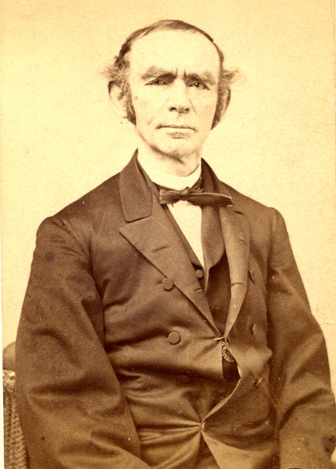
Biography: Born in Bavaria, Germany in 1809, Rabbi Einhorn was educated at the rabbinical school in Fürth. He emigrated to the United States and was named in 1855 as the first rabbi of the Har Sinai Congregation in Baltimore, Maryland.
In 1861, Rabbi Morris Raphall delivered a sermon in New York which endorsed slavery, stating that it was allowed by the bible. In response Einhorn gave a sermon rebutting Raphall. He attacked not only slavery but also what he saw as rabbinic misuse of the Torah and the misalignment of American Judaism with history’s enslavers and persecutors. Einhorn argued that Jews should act in ways progressive, moral, and self-consciously Jewish. Jews should speak as full citizens about large political matters, but they had to speak in a way that revealed clearly the deep morality of Judaism. He stated that whilst slavery was acknowledged in the Torah, it was not sanctioned in it and that it was inconsistent with Jewish values.
Einhorn’s sermon was a brave move as he had previously avoided political advocacy. Maryland was at the time still a slave state (51% of its African-American population were slaves) and many of his congregants and colleagues were sympathetic to slavery.
‘The ten commandments, the first of which is: "I am the Lord, thy God, who brought thee out of the land of Egypt,—out of the house of bondage" can by no means want to place slavery of any human-being under divine sanction.’
‘I am no politician and do not meddle in politics. But to proclaim slavery in the name of Judaism to be a God-sanctioned institution—the Jewish-religious press must raise objections to this, if it does not want itself and Judaism branded forever.’
[On Raphall]: ‘The question simply is: Is Slavery a moral evil or not? And it took Dr. Raphall, a Jewish preacher, to concoct the deplorable farce in the name of divine authority, to proclaim the justification, the moral blamelessness of servitude, and to lay down the law to Christian preachers of opposite convictions. The Jew, a descendant of the race that offers daily praises to God for deliverance out of the house of bondage in Egypt, and even today suffers under the yoke of slavery in most places of the old world, crying out to God, undertook to designate slavery as a perfectly sinless institution, sanctioned by God. I, and the impudent persons who will not believe this, are met with fanatical zeal, with a sort of moral indignation!’
A matter of weeks after Einhorn’s sermon, a riot broke out, his press was destroyed (he ran a German Jewish magazine called Sinai) and he was forced to flee his congregation, his home and his adopted town. Einhorn fled to Philadelphia where he became Rabbi of Congregation Knesset Israel.

Helen Suzman
Context: Apartheid was a system of racial segregation in South Africa enforced through legislation by the National Party governments (the ruling party from 1948 to 1994), under which the rights, associations and movements of the majority black inhabitants were curtailed and Afrikaner minority rule was maintained.
Legislation classified inhabitants into four racial groups, “black”, “white”, “coloured”, and “Indian” and residential areas were segregated. From 1960-1983, 3.5 million non-white South Africans were removed from their homes and forced into segregated neighbourhoods. Non-white political representation was abolished in 1970, at the same time as black people were deprived of South African citizenship. The government segregated education, medical care, beaches and other public services, providing black people with services inferior to those of white people.
The National Party passed a string of legislation that became known as petty apartheid. The first of these was the Prohibition of Mixed Marriages Act 55 of 1949, prohibiting marriage between whites and people of other races. The Immorality Amendment Act 21 of 1950 then forbade "unlawful racial intercourse" and "any immoral or indecent act" between a white and an African, Indian or coloured person.
Blacks were not allowed to run businesses or professional practices in areas designated as "white South Africa" unless they had a permit. They were required to move to the black "homelands" and set up businesses and practices there. Transport and civil facilities were segregated. Black buses stopped at black bus stops and white buses at white ones. Trains, hospitals and ambulances were segregated. Because of the smaller numbers of white patients and the fact that white doctors preferred to work in white hospitals, conditions in white hospitals were much better than those in often overcrowded and understaffed black hospitals. Blacks were excluded from living or working in white areas, unless they had a pass, nicknamed the dompas ("dumb pass" in Afrikaans). Only blacks with "Section 10" rights (those who had migrated to the cities before World War II) were excluded from this provision. A pass was issued only to a black with approved work. Spouses and children had to be left behind in black homelands. A pass was issued for one magisterial district (usually one town) confining the holder to that area only, being without a valid pass made a person subject to arrest and trial for being an illegal migrant. This was often followed by deportation to the person's homeland and prosecution of the employer for employing an illegal migrant.

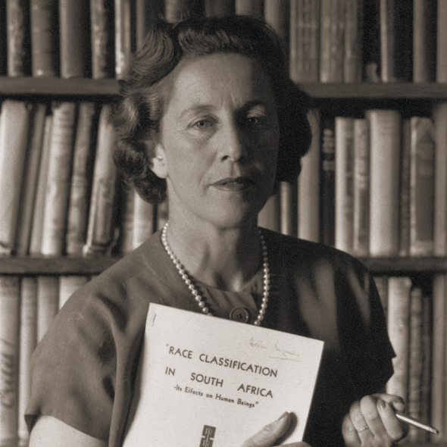
Biography: Helen Suzman was born in the South African mining town of Germiston in 1917 to Samuel and Frieda Gavronsky, both immigrants from Eastern Europe who had come to South Africa to escape the restrictions imposed on Jews by Russia.
In 1952 Helen entered a nomination contest for a parliamentary seat in the 1953 election. She won the contest and represented the United Party (UP) in Parliament that year.
In 1959, 12 MPs, including Helen, broke away from the United Party and subsequently formed the Progressive Party, with an openly liberal programme of extending rights to all South Africans with a qualified franchise. In the general election of 1961, the Progressives were virtually wiped out, and only Helen retained her seat.
For 13 years, with both the National Party and the United Party supporting apartheid, Helen was the sole voice of opposition in South Africa’s parliament (1 out of 166 MPs). Suzman became known for her strong public criticism of the governing National Party's policies of apartheid at a time when this was unusual amongst white people. She found herself even more of an outsider, as she was an English-speaking Jewish woman in a parliament dominated by male Afrikaners.
While Helen Suzman’s main concern lay with apartheid’s erosion of civil liberties and the rule of law, and its appalling human costs, she also concerned herself with the abolition of capital punishment and gender discrimination, particularly as it affected African women whose status in customary law was that of “perpetual minors.” In 1988 she was instrumental in having matrimonial legislation enacted that greatly improved the legal status of women.
In 1974, six colleagues joined Helen in Parliament and the Progressive Party was renamed the Progressive Federal Party. As a Member of Parliament, she used her parliamentary immunity to speak out when other avenues of protest were harshly suppressed, visiting prisons, among them Robben Island, where she inspected the living conditions of prisoners.
Her struggle against apartheid won her the United Nations Human Rights Award in 1978 and the Medallion of Heroism in 1980. She was nominated for the Nobel Peace Prize twice.
In a famous exchange in parliament, an irritated cabinet minister shouted, “You put these questions just to embarrass South Africa overseas,” to which Suzman replied, “It is not my question that embarrasses South Africa—it is your answers.”
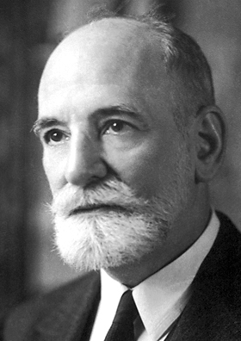
René Cassin
Context: With the end of the Second World War, and the creation of the United Nations in 1946, the international community vowed never again to allow atrocities that took place to happen again. World leaders decided to complement the UN Charter (the foundational treaty of the United Nations) with a road map to guarantee the rights of every individual everywhere. The UN Commission on Human Rights, which was established following the formation of the UN, was tasked with creating this document.
The Commission consisted of 18 members from various nationalities and political backgrounds. René Cassin was the representative from France. The Universal Declaration of Human Rights was adopted by the UN General Assembly on 10 December 1948.
Biography: Born in 1887 in Bayonne, France. In 1918 René Cassin founded a charity for men permanently injured in the War called ‘The French Federation of Disabled War Veterans’ and remained the President or Honorary President until 1940.
After qualifying as a lawyer, Cassin became a Professor of Law at the University of Aix-en-Provence and then the University of Paris. He was a French delegate to the League of Nations from 1924 to 1938. Here he pressed for progress on disarmament and developing institutions to aid the resolution of international conflicts.
René Cassin persistently worked on the development of international human rights protection, urging the creation of an international court to punish war crimes in 1942. He was a delegate to the United Nations Commission on Inquiry into War Crimes (1943-1945) and frequently served as a delegate for the French Government to the UN General Assembly and UN Educational, Scientific and Cultural Organisation (UNESCO). Cassin was president of the Hague Court of Arbitration from 1950-1960 and a member and later president of the European Court of Human Rights between 1959-1968.
Following the atrocities of the Holocaust, Cassin, together with Eleanor Roosevelt, wrote the Universal Declaration of Human Rights. The UN General Assembly approved the declaration on December 10, 1948. The UN honoured and commended Cassin’s work on behalf of human rights activism with the Human Rights Prize, and in 1968, René Cassin was awarded the Nobel Peace Prize.
The Jewish human rights charity René Cassin was established after its founders were inspired to follow in Cassin’s footsteps as a Jewish voice on international human rights.
Rabbi Abraham Joshua Heschel
Context: Following the end of the American Civil War (a victory for the Abolitionists), slavery was made illegal and all black Americans who had been enslaved were declared free. Although Constitutional amendments called for equal protection and fair treatment of African-Americans, a barrier between legislation and practice remained. States, particularly Southern states, passed laws that facilitated segregation. Specifically, these Jim Crow laws mandated racial segregation of African-Americans from white Americans in all public areas including transportation, schools, drinking fountains, restaurants and restrooms. Laws were also passed that made it difficult, if not impossible, for most of the South’s black population to vote. Those who could not vote were not eligible to serve on juries and could not run for local offices. Forty years after the end of slavery, the previously thriving black middle class had all but disappeared.
With African-American interests ignored in the South, schools for black children were consistently underfunded compared to schools for white children. Similarly public libraries for African-Americans were either underfunded or didn’t exist at all. A lack of support for America’s black population, most of whom lived in the South, meant that until the laws changed, it was near impossible for them to change their social situation.
Out of this inequality grew the American Civil Rights movement in the 1950s. An array of organisations organised boycotts, sit-ins, freedom rides and marches along with a wide range of other non-violent activities.
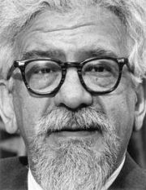
Biography: Born in Poland in 1907 as the youngest of six children, Heschel was descended from preeminent European rabbis on both sides of his family. After a traditional yeshiva education and studying for Orthodox rabbinical ordination semicha, Heschel pursued his doctorate at the University of Berlin and a liberal rabbinic ordination at the Hochschule für die Wissenschaft des Judentums. In late October 1938, when Heschel was living in a rented room in the home of a Jewish family in Frankfurt, he was arrested by the Gestapo and deported to Poland. He spent ten months lecturing on Jewish philosophy and Torah at Warsaw's Institute for Jewish Studies. Six weeks before the German invasion of Poland, Heschel left Warsaw for London.
Heschel arrived in New York City in March 1940. He served on the faculty of Hebrew Union College (HUC), the main seminary of Reform Judaism, in Cincinnati for five years. In 1946, he took a position at the Jewish Theological Seminary of America (JTS) in New York City, the main seminary of Conservative Judaism.
Heschel's experience during the Holocaust and his study of the Jewish prophets influenced his belief that Judaism required of one both deeds and actions. In 1965 Professor Abraham Joshua Heschel went to Selma, Alabama, to march with Martin Luther King Jr. in the struggle for civil rights.
When he came home from Selma in 1965, Heschel wrote, "For many of us the march from Selma to Montgomery was about protest and prayer. Legs are not lips and walking is not kneeling. And yet our legs uttered songs. Even without words, our march was worship. I felt my legs were praying."
After the assassination of King, Heschel said of him: "Martin Luther King is a sign that God has not forsaken the United States of America...I call upon every Jew to hearken to his voice, to share his vision, to follow in his way. The whole future of America will depend upon the influence of Dr. King."
About Heschel, King described him as "one of the great men of our age, a truly great prophet...He has been with us in many struggles. I remember marching from Selma to Montgomery, how he stood at my side."
One of the most prominent rabbis in the Civil Rights movement, Heschel served as professor of Jewish ethics and mysticism in New York until his death in 1972.
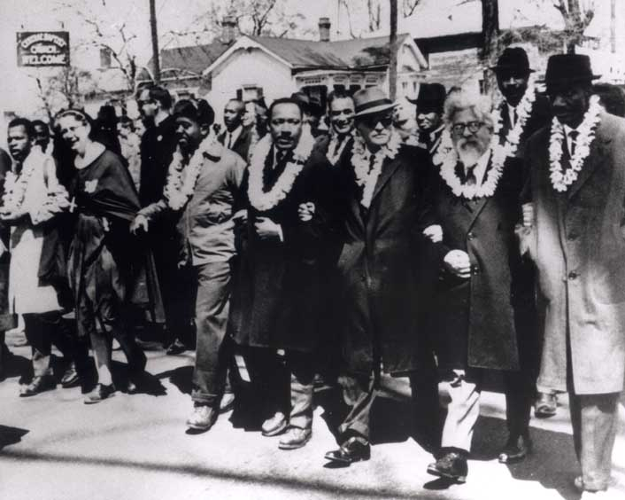

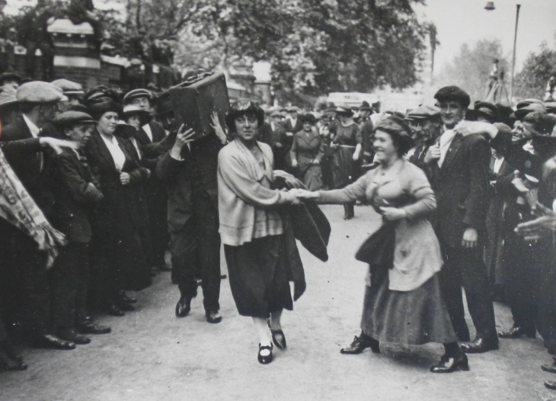
Minnie Lansbury
Context: Until 1832 and then 1835, women had been prohibited from voting in the UK. After the Reform Act of 1932 however, they weren’t explicitly banned but the vote was only extended to men. Having originally just been a political issue, it wasn’t until 1972 with the creation of the National Society for Women’s Suffrage that women’s suffrage (the right to vote in political elections) became a national movement. Between the 1870s and 1903, all campaigning was conducted peacefully and constitutionally, however after the failure of the first Women’s Suffrage Bill, the Pankhurst sisters founded the Women’s Social and Political Union (WSPU), which advocated more direct militant action (demonstrations, stone-throwing, arson, window smashing and hunger strikes). The WSPU was considered to have been extremely influential to the cause – drawing attention to the necessity for change through their continued presence in the public eye.
Biography: Born in 1889, the daughter of a Jewish coal merchant, Minnie Lansbury was a leading suffragette and council member on the first Labour-led council in the Borough of Poplar.
Minnie Lansbury became a teacher, and joined the east London suffragettes in 1915. She was also chairman of the War Pensions Committee, fighting for the rights of widows, orphans and wounded from World War I. She was elected alderman on Poplar’s first Labour council in 1919, before women received Parliamentary suffrage.
Poplar was a poverty-stricken borough. Due to severe poverty and unemployment, taxes were low; despite this each borough was still expected to cover the costs of its own services. Coupled with this, the council was expected to tax its constituents for services such as the London County Council and the Metropolitan Police (precepts).
At its meeting on 22 March 1921 the Poplar Council resolved not to make its precepts and to apply these revenues to the costs of local poor relief. This illegal action created a sensation, and led to legal proceedings against the council. On 29 July Millie Lansbury and the 29 other councillors involved (Millie was one of five women) marched in procession from Bow to the High Court, headed by a brass band. Informed by the judge that they must apply the precepts, they would not budge and refused to levy the full rates. Early in September, Lansbury and her fellow-councillors were imprisoned for six weeks for contempt of court. Due to her imprisonment, she developed pneumonia and died in 1922.
She was buried in the Jewish cemetery in East Ham.

Who is a refugee? – 1 hour
Aims:
- Chanichim to understand and be able to explain what a refugee is.
- To be able to name a country refugees come from and a country they go to
- To be able to state present day issues that create force people to leave their country and reasons why they go to certain countries.
Trigger: (5 minutes)
Protector vs. Enemy
- Protector vs. enemy – everyone in a circle must choose one protector and one enemy and make sure that their protector is always between them and their enemy.
Trigger 2: (15 minutes)
- Split into four groups
- Each group is given an A1 sheet
- They must write down what they think the word ‘Refugee’ means, and thoughts they associate with it, any questions they have and any relevant words they think go with it/are associate with it.
- Everyone comes back together to discuss what was written by each group, going over:
  - definition
  - what motivates people/forces people to leave their homes
  - different instances through history past and present of refugees
Method (15 minutes):
Prep:
An A3 map of the world is placed in the four corners of the room. By each one are 8 thin pieces of card with blue tack on the bottom (2 blue, 2 green, 2 yellow, 2 red).
- Each group is given a piece of paper on which they must write the top 4 countries they think refugees come from and the top 4 countries they think currently host refugees.
- Each group is then given a colour (one of the four from above) and a mode of transport
  - Flying (enacted by walking with big steps – must walk as a group though)
  - Walking (enacted by walking on knees)
  - Boat (the group has two flip-chart sized pieces of paper that they must stand on to move around)
  - Car (group must sit on their chairs together and shuffle the chairs forward to move)
- Using their mode of transport as a group, at each map they must:
  - place markers down over the four countries they think the most refugees are from
  - place markers down over the four countries they think host the greatest number of refugees
Sikkum (25 minutes):
- Each group is given a fact sheet about a country refugees come from and a country currently hosting refugees. After filling out the second part of their form using the fact sheet, the groups all mix so that there is one person from each group in the other groups.
- Here they must each share what they have learnt with each other, revealing where most refugees in the world come from and which countries are currently hosting the most refugees.
- As one big group, the correct countries are placed on the map in the middle of the room.
- A discussion is then had as to why people have fled these countries, why these countries host the most refugees, some of the issues that come about because of this and potential solutions to refugee crises.
Resources:
A1/A2 (flipchart sized) paper Marker pens 5 A3 labelled colour map of world
Coloured card (for cutting up into thin strips to act as markers) Blue tac Pens
Refugee:
A person who owing to a well-founded fear of being persecuted for reasons of race, religion, nationality, membership of a particular social group or political opinion, is outside the country of his nationality and is unable or, owing to such fear, is unwilling to avail himself of the protection of that country; or who, not having a nationality and being outside the country of his former habitual residence as a result of such events, is unable or, owing to such fear, is unwilling to return to it.”
The 1951 United Nations Convention Relating to the Status of Refugees

I believe most refugees come from:
- ...........................................................................
- ...........................................................................
- ...........................................................................

- ...........................................................................
I believe the top-four countries hosting refugees are:
- ...........................................................................
- ...........................................................................
- ...........................................................................

- ...........................................................................

Some refugees come from
Country:
Number:
Interesting fact:

There are refugees currently living in
Country:
Number:
Interesting fact:

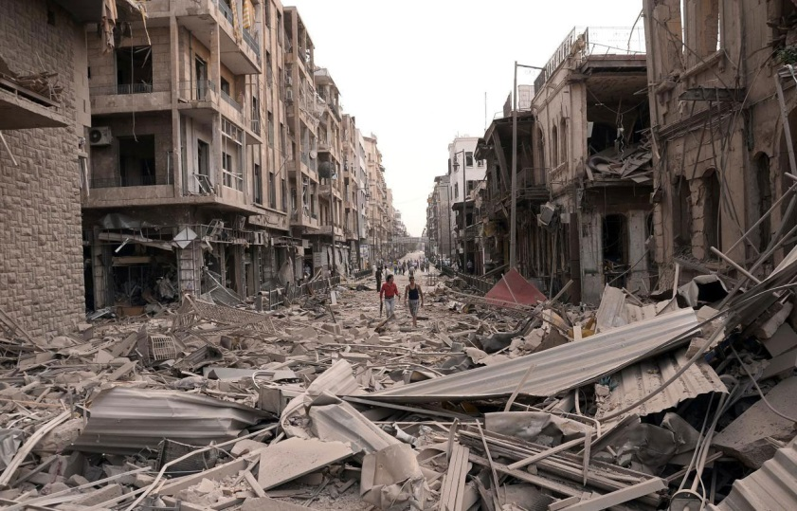
Syria
Over 4.9 million people have now fled Syria because of the civil war that began in early spring 2011. The conflict began when President Bashar al-Assad responded to nationwide protests with violent crackdowns.
There are now a number of groups fighting for control of areas within Syria. One of them, Daesh, seized large parts of Syria in 2014. They have persecuted a minority group in Syria called Yazidis, forcing many to flee their homes.
Over 400,000 people are thought to have been killed in the conflict, many of them civilians. With no end in sight, the number of refugees is expected to increase in the future.
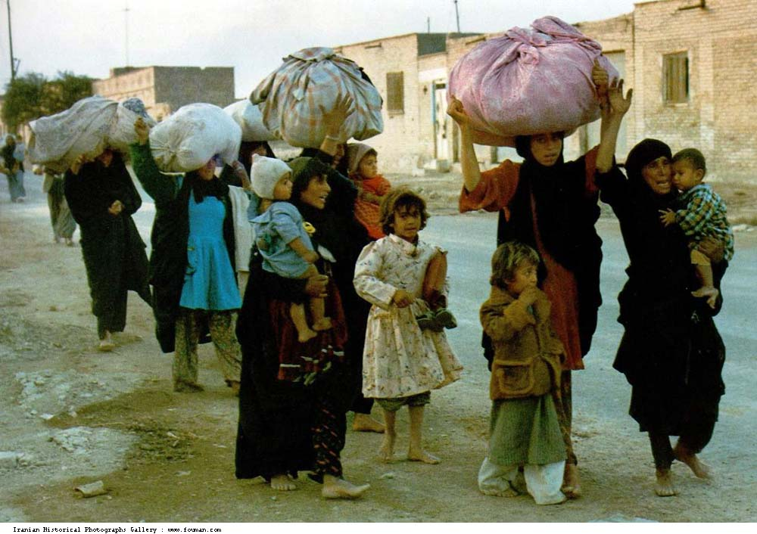
Iran
There are around 979,400 refugees currently living in Iran. The majority of refugees are from Afghanistan (950,000) and have lived in Iran for over ten years, however there are also some from Iraq. The number of Iraqi refugees has increased in the past two years as the Syrian civil war has spilled over into Iraq.
Throughout the 1980s and early 1990s Iran provided asylum to over 1 million Iraqi refugees (mostly Kurds) who were escaping the Iran-Iraq war.
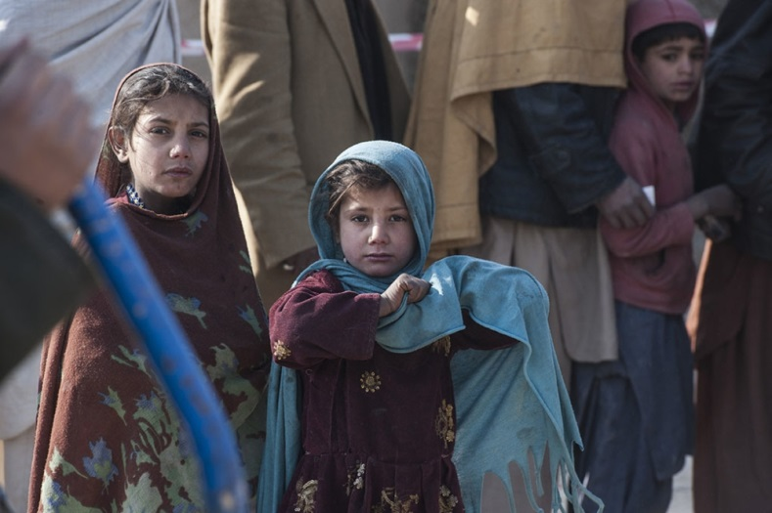
Afghanistan
There are around 2.7 million Afghan refugees in the world. Constant warfare in the country since the late 1970s has meant that refugees have been continually fleeing the country right up to the present day.
Over 6 million left Afghanistan during the Soviet war there between 1978-89. This was followed by a Civil War and then five years of Taliban rule, followed by the international invasion of Afghanistan in 2001 to remove the Taliban.
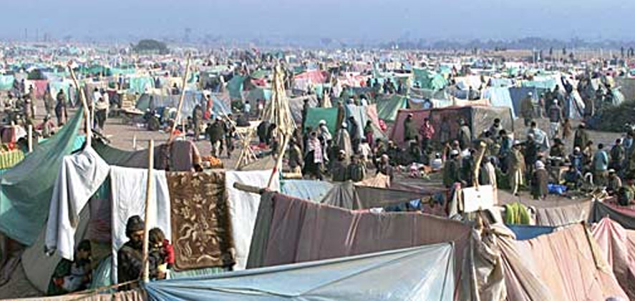
95% of Afghan refugees are located either in Pakistan or Iran, which both share a border with Afghanistan.

Pakistan
Pakistan hosts 1.6 million refugees, almost all of whom are from Afghanistan. Approximately one-third of the Afghan refugees in Pakistan live in refugee villages. Two-thirds live in urban and rural host communities. Since 2002, over 3.5 million Afghan refugees have returned to Afghanistan from Pakistan.

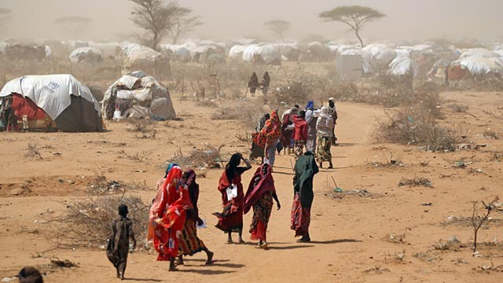
Somalia
Somalia has been engulfed in conflict since the Siad Barre regime collapsed in 1991. It is estimated that over 500,000 people have been killed due to the civil war since then.
There are over 1.1 million Somali refugees in the world, the vast majority of whom live in the neighbouring countries such as Kenya, Ethiopia and Yemen. The government installed in Somalia in 2012 controls does not control all of the country. Control in many areas is fragile in the face of tension between competing warlords and frequent attacks from the Al Shabab terrorist group.
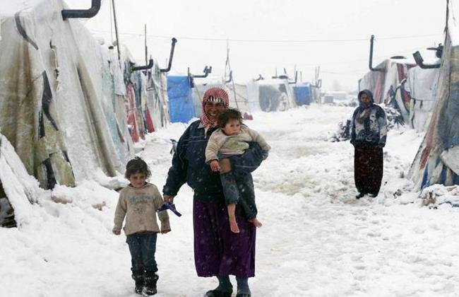
Lebanon
Due to its close proximity to Syria, Lebanon has been heavily impacted by the Syrian civil war. There are over 1.1 million Syrian refugees living in Lebanon. Roughly 1-in-5 persons in Lebanon is a Syrian refugee.
Refugees have access to most basic services through public institutions, where the authorities continue to play an active role in facilitating response coordination and planning. The sheer number however has put great pressure on Lebanon and there are fears that without assistance it will be unable to offer the full support refugees need.

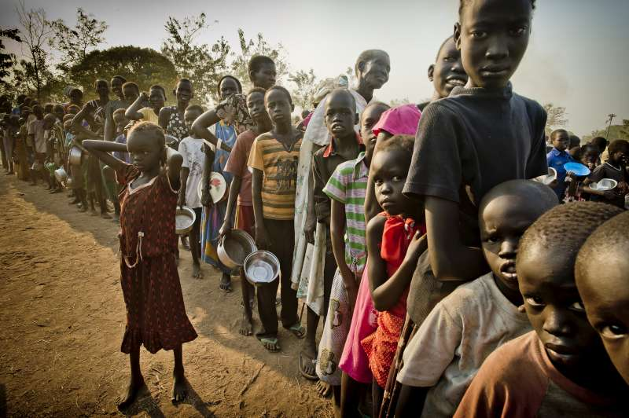
South Sudan
South Sudan is the world’s youngest country, having only been established in 2011 following a vote for independence. Despite this it has been beset by conflict. Prior to its establishment, thousands were displaced due to the Second Sudanese Civil War, a conflict that lasted twenty-two years and killed over a million individuals.
Two years after South Sudan declared independence, the South Sudanese Civil War broke out. The as yet unresolved conflict has killed over 10,000 people and forced many to leave their homes. There are roughly 778,700 South Sudanese refugees, who principally live in refugee camps in the neighbouring countries of Ethiopia, Uganda, Sudan and Kenya.
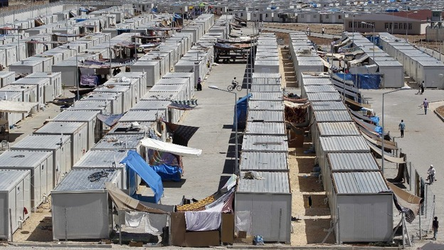

Turkey
Turkey hosts over 2.5 million refugees, the vast majority of whom are from Syria, with whom it shares its southern border. Over half of the Syrian refugees living in Turkey are children.
Turkey has maintained an emergency response of a consistently high standard and declared a temporary protection regime, providing assistance in 22 camps, where a quarter of the refugees are currently living. Despite this, Turkey has been criticised for failing to ensure Syrian children can access education and adults can work.

Journey to WALL-E’S World – 90 minutes
Aims:
- For the chanichim to think about some of the struggles asylum seekers go through.
- For chanichim to think about some of the misconceptions and preconceived attitudes towards asylum seekers.
- To engage with the idea of privilege.
Idea:
Pixar is in dire shape. It faces collapse after a series of catastrophes have left all its films at risk of disappearing along with all their characters.
- The grasshoppers are invading the colony in A Bug’s Life
- The toys are going to be thrown away in Toy Story
- The reef is being slowly destroyed in Finding Nemo and much of is it uninhabitable
- The rats are being told they must leave the kitchen in Ratatouille.
- The monsters are running out of energy to power their world in Monsters Inc. and are living in poverty.
- The superheroes of The Incredibles are being arrested for endangering the population and criminal damage.
Each group of characters from the Pixar films have therefore been forced to leave their worlds to seek a new home, ensuring that their films will still be accessible. They have all heard that WALL-E’s World is a safe haven for them and have all decided to get there. There also exist Pixar notes which can help them on their way (the Pixar equivalent of money).
Trigger (10-15 minutes):
Chanichim are divided into the six groups and each given a passport (see resources).
They are told to fill in their passport (name and image) and their madrich/a explains to them (in colourful detail) that they must all leave their films, the reason why they must leave and where they are going.
At this point the madrich/a should also explain how they should go about reaching WALL-E’s World and hand out the Pixar notes.
- Group 1 - all members receive 5 tokens each
- Groups 2 and 3 - 3 tokens per person
- Groups 4 and 5 - 2 tokens per person
- Group 6 – 1 token per person
It is up to the chanichim if they keep their own notes individually or pool them.
Method (45 minutes – 1 hour):
Groups each have dice (a giant one if possible) and use it to determine where they must go. Each number leads to a particular task or challenge.
There also exist “gates”, which are the entrances into WALL-E’s World. Upon successfully completing the challenge at the gate, 2-5 of the group’s passports (depending on the size of the groups) get stamped. Only when all of the group’s passports have been stamped can the group pass through a gate to WALL-E’s World.
Rolls:
1 The Working Challenge 1
- Groups must pay 1 pixar note to receive a Sudoku.
- Upon successfully completing a Sudoku individuals receive 3 pixar notes
- Most of them should be easy, some medium, and a few hard
- Madrichim should mix it up so that sometimes they barely check the answers and at others they check properly
2 Gate 1 Disney Court
- In front of judges (madrichim) – chanichim must plead their case, explaining why they have been forced to leave their movie and what skills they bring to WALL-E’s World.
- Presentations to the judges can be:
  - A speech on behalf of the whole group
  - A speech on behalf of oneself
  - A dramatic production
  - An interpretive dance
  - A musical
  - Any other form the madrichim think appropriate
- If two groups arrive at the same time, a dance-off/rap battle. Whichever group make the better impression/more convincing argument successfully get some of their group’s passports stamped. The losing group gets nothing.
3 The Working Challenge 2
- Groups must build a paper aeroplane fleet (5 planes in a fleet).
- Each piece of paper (for an aeroplane) costs 1 Pixar note
- All 5 aeroplanes must be able to fly over 7 metres.
- Upon completion of a successful fleet, 16 Pixar notes are received.

4 Gate 2 Boat Over Troubled Water
- A cost of 1 Pixar note each (the whole group must participate) to enter.
- If one group, the group has one chair per-person and must use the chairs to get across DiSnea (silent ‘n’) (an expanse of grass is preferable).
- Upon completion some of the group get their passport stamped.
- If two groups converge at the same time (or in quick succession) – they must pay the charge and then race across. In this instance they have one chair per-person plus one spare. The losing group does not get their passport stamped.
5 Gate 3 The Queue
- One stand (two if it’s very busy) – Official Entrance to WALL-E’s World.
- Single file line.
- At the beginning the stand is unmanned (until a queue develops).
- Waiting time should be around 3-5 minutes.
- 2-4 from the group get their passports stamped (in no particular order). The others are told by the person at the desk to come back later when it’s less busy.
6 Gate 4 The Balloon Man/Woman
- It costs 5 Pixar notes for the group to be taken to this gate (the group can refuse to pay and must then roll again).
- Once at the gate, the group is made to wait for 5 minutes.
- After 5 minutes they are refused entry.
- As they leave they are secretly approached by a balloon man/woman (madrich/a with balloons on them – like the house in UP).
- They offer to take 2-3 members of the group to WALL-E’s World through a secret route.
- However it will cost 5 Pixar notes per person. A maximum of 3 people can be taken.
- Those that do go (the group can say no and stay together, but the balloon man/woman should try to convince them to send a couple of people) are taken on a round-about route, hiding from other groups/madrichim on the way to get to WALL-E’s World.
The first to make it into the mountain (maybe a hall if that’s where they started, or a hidden space outside?) will be given luxuries, comfy chairs, squash, an ice cream? However those that make it in towards the end will not.

Sikkum (15-20 minutes):
Groups will split again so there are a couple from each group all together. Form of a discussion about the session:
- What was easy, what was hard?
- The different experiences each group had.
- How might the challenges they did tie in to real world issues
- What made sense and what didn’t.

For the madrichim to consider when guiding the discussions:
- Inequality/Privilege – groups receiving different amounts of money.
- Gate 1 – expectation of what a claim might look like – is purely explaining what happened not enough? Is it fair that groups are asked to compete over who has the “worse” situation to escape from? Is it important that groups had something to contribute to WALL-E’s World or should it have been more important that they reached it safely?
- Gate 2 – were certain challenges harder than others? i.e. boat-chairs more strenuous than gate 1?
- All Gates – arbitrary nature of deciding who gets a stamp and who doesn’t. Filling a quota? Did chanichim feel respected?

Resources:
See below for further resources
Giant dice/regular dice (x6) Balloons Pens Chairs Paper
Sudoku (mainly easy, some medium, a few hard) Ice Cream/Food?

Chanichim should be warned that their Pixar Passports can be confiscated (for failure to finish a task or stepping out of line) – however this won’t actually happen – more just so that they have the threat hanging over them.
Although there is a natural time limit for how long the session can last – chanichim should be aware of some form of time constraints to increase their urgency to reach WALL-E’s World.
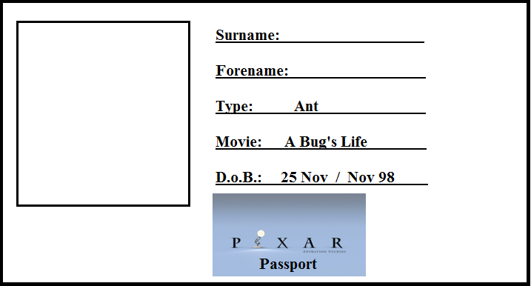
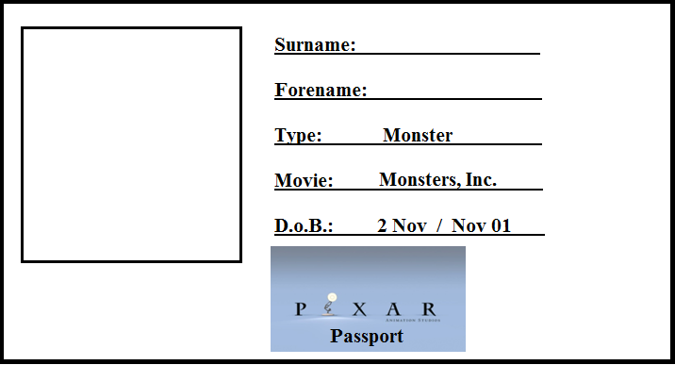
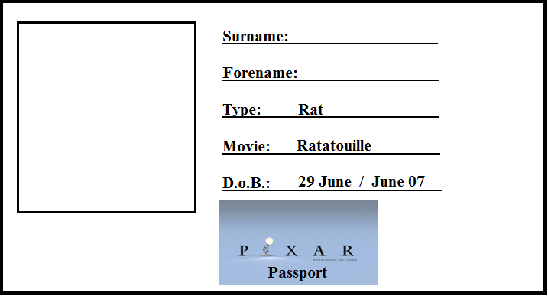
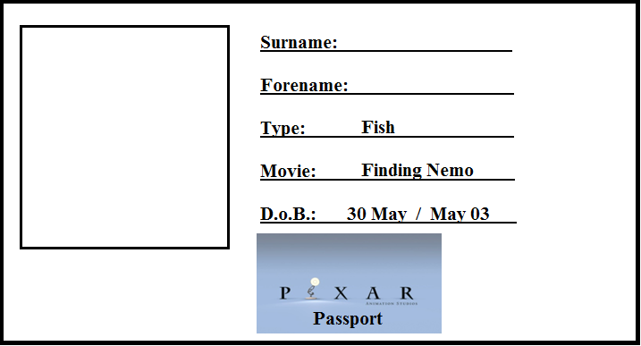

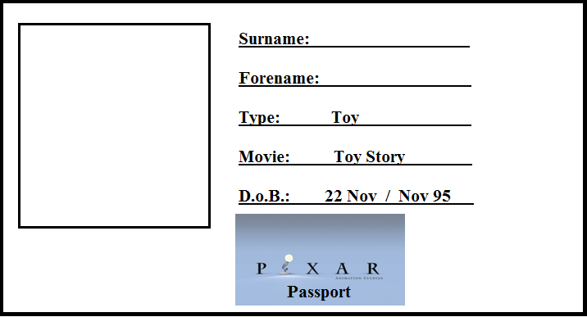

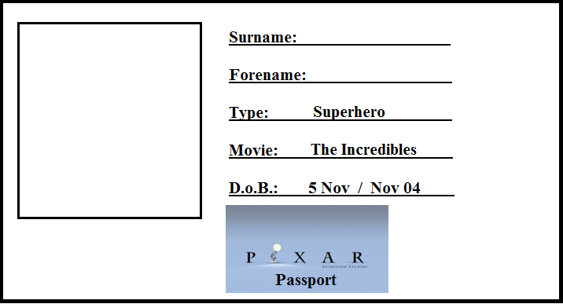

The Dot Game – 1 hour
Aims:
- To encourage the chanichim to think about empowerment and disempowerment.
- To encourage chanichim to engage with and understand discrimination.

Trigger (15 minutes):
The chanichim must stand in a circle with their eyes shut.
Madrichim have three sheets of little small coloured dot stickers (green, blue and yellow). They must go round sticking a dot on the forehead of the chanichim, forming three equal groups. Without talking, the chanichim must sort themselves into the three groups, divided by their colour dot. Chanichim must not take off their sticker to see what colour they are.
Once in their groups, discuss with the chanichim how they felt having been selected in this way. Was it difficult working out which group they were meant to belong to?
Method (30 minutes):
Part 1 – 10 minutes:
The Yellow Dots are ushered into the corner of the room and must stand in silence facing the corner.
The Blue Dots are told that they are now in charge of the Green dots and can give them orders (orders such as those found in Simon Says). They are free to play a game, so long as it is just amongst the Blue Dots.
The Green Dots are told that they must obey the Blue dots without argument.
Part 2 – 10 minutes:
A madrich/a comes running in to interrupt the activity saying there has been a terrible mistake and the wrong instructions were given.
The Blue Dots must stand silently in the corner.
The Green Dots are in charge of the Yellow Dots.
The Yellow Dots must obey the Green Dots without argument.

Part 3 – 10 minutes:
The same madrich/a comes running in again to interrupt the activity asking ‘What’s going on? This isn’t what I said earlier! What I said before was:
The Green Dots must stand silently in the corner.
The Yellow Dots are in charge of the Blue Dots.
The Blue Dots must obey the Yellow Dots without argument.
Sikkum (15 Minutes):
The chanichim, staying in their groups, separate for a discussion. After getting the chanichim to take off their stickers, discuss with them how they felt. Was it fair that one group had more power than the others? Which role did they prefer to be in? Why? What did it feel like to be inside a group? What did it feel like to be outside a group and separated from their friends? Who decides what is fair in their family, amongst their friends, or on a summer camp/in a youth group? Is that fair? Who else in life decides what is fair? Why are they able to make the decisions?
Each group should appoint one or two speakers to present their group’s thoughts to everyone else, then bring them back together to share. (The madrich/a who’s leading the discussion might want to write down their groups thoughts).
Resources:
Enough stickers for all the chanichim – an even divide of blue, green and yellow.
A1/A2 paper (flipchart size) and pens for Sikkum.

The Tikkun Olam Court – 70 minutes
Aims:
- For the chanichim to think about responsibility and whose responsibility issues in the world are.
- For the chanichim to learn about and understand the concept of Tikkun Olam and the various levels of responsibility in repairing the world.

Trigger (15 minutes):
Placed on the floor are five concentric circles (probably best made using masking tape as it needs to fit the whole group in with space to spare).
Each circle represents a different level of Tikkun Olam.
The innermost circle to the outermost circle:
- Tikkun Atzmi – repairing the self/individual
- Tikkun Kehila – repair of one’s community (or school)
- Tikkun Am – repair of the Jewish people
- Tikkun Medinat – repair of one’s country (usually it might mean the Jewish state but here we’re going for one’s country)
- Tikkun Olam – repair of the world
Some would argue that Tikkun Olam can only be achieved if each step before it has also been accomplished.
The madrich/a reads out statements and chanichim must decide whose responsibility it is first and foremost (the individual’s, the community/school’s, the Jewish people’s, the UK’s or the world’s).
Potential statements: Recycling. Fighting racism. Bringing peace to the Middle East/Ending the Israeli-Palestinian conflict. Ensure you get a good education. Make sure that people are eating healthily. Cutting Carbon emissions. Make sure chanichim feel included on events.
After each statement is read, the madrich/a should get a couple of chanichim standing on different circles to explain why they are standing where they are.
The final statement should be ‘Who should be responsible for where asylum seekers go?’ (the individual (asylum seeker), the asylum seeker’s community, their people religious/ethnic group, their country or the world)

Method (45 minutes):
Hopefully roughly half the group stand in the centre (the asylum seeker’s responsibility/right to decide where they go) and half the group will stand on the outside (the world has a responsibility).
Rather than having a discussion about it, both groups are told that they will each be representing their client in the States of the World vs. the Individual at the Tikkun Olam Court.
- States of the World – arguing that it is the world’s responsibility to find places and decide where they go.
- The Individual – arguing that it is down to the individual asylum seeker to decide where to go.
Each group must nominate one judge who will sit with a madrich/a as the panel of judges presiding over the case. The three judges are not there to pronounce a judgement at the end but rather to maintain order, clarify statements and ask questions to further investigate groups’ arguments.
Groups should consider:
- Why it is the responsibility/right of their client
- Case studies/current issues
- Morality vs. Logistics
- Human Rights
Structure:
- 15 minutes - prep
- 10 minutes - 1st Statement
- 5 minutes - prep
- 10 minutes - rebuttals/responses
- 5 minutes - questions from judges

Sikkum (10 minutes):
Split into groups of 6 (3 from each side – judges are included in this section) to form their own mini-juries. Must discuss their own thoughts after the case and return to the group as a whole their own verdict (either unanimous decision or split verdict).
If split verdict – jury can reconvene over dinner to discuss.

Resources:
Pens, paper. http://www.theguardian.com/world/2014/jun/25/-sp-boat-migrants-risk-everything-for-a-new-life-in-europe
http://www.theguardian.com/world/2014/jun/20/uk-24-syrians-vulnerable-persons-relocation-scheme

The Bible – a tale of immigration and asylum – 1 hour 10+
Aims:
- To engage the chanichim with examples of migrants and refugees in biblical Jewish history;
- To engage with the human stories of immigration and asylum through biblical Jewish history;
- To break down common misconceptions about migrants and refugees.
Trigger: (22 minutes)
5 minutes
- Chanichim play huggy jellyfish.
  - Everyone walks around individually. A number is shouted out. People must congregate in groups of that number.
  - Eventually splitting into 5/6 groups (3-6 per group depending on numbers).
14 minutes: 7 mins writing - 7 going over what they wrote/definitions
- Each group is given a flip-chart sized sheet for each group with the words: Refugee, Migrant, Citizen, Trafficked Individual, Stateless Person on it.
- In their groups chanichim must write what they think each word/phrase means, anything else relevant that comes to mind and any questions they have.
- Everyone then comes back together for a quick discussion
- The sheets are flipped over to reveal the same words with the official definitions
Method: (30 minutes)
10 minutes
- Each group is handed one of the following stories, from the perspective of:
  - Cain: his murder of Abel and his punishment by God
  - Noah and the flood
  - Hagar: the birth of Ishmael and their expulsion in the Desert
  - Jacob: the blessing of Isaac/flight to Laban and the famine and taking his family to Egypt
  - Joseph: kidnap and selling into slavery by his brothers
  - the Israelites: their exodus from Egypt
- Chanichim must decide how their individual/group should be classified using the definitions. They must consider what motivated their individual/group, what pressures might have been on them, what factors they would have to take into account, what risks they might be taking.
20 minutes
- Each group must then present to the rest of the chanichim, allowing a brief time for discussion at the end of each presentation for other groups to ask any questions and offer their thoughts on it.
Sikkum: (18 minutes)
- Around the wall more modern (20th Century-present day) stories of refugees, migrants, unaccompanied asylum seeking young people and stateless persons are put up and the chanichim are given the opportunity to walk round, reading the stories/seeing the pictures.
- Everyone comes back as one big group for a discussion on what they thought of the modern day stories, any links they see to the biblical stories and any other thoughts they have.
Resources:
A1/A2 (flipchart sized sheets) Marker pens for writing
Definitions:
- Refugee:
A person who owing to a well-founded fear of being persecuted for reasons of race, religion, nationality, membership of a particular social group or political opinion, is outside the country of his nationality and is unable or, owing to such fear, is unwilling to avail himself of the protection of that country; or who, not having a nationality and being outside the country of his former habitual residence as a result of such events, is unable or, owing to such fear, is unwilling to return to it.”
The 1951 United Nations Convention Relating to the Status of Refugees
- Migrant:
A person who moves, either temporarily or permanently, to live in a new country.
An individual might move for a number of reasons, including looking for work/taking up a new job, escaping poverty/destitution, joining up with family.
- Citizen:
A legally recognized subject or national of a state or commonwealth, either native or naturalised.
- Stateless Person:
One “who is not considered as a national by any State under the operation of its law.” A stateless person has no citizenship or nationality of any country.

- Trafficked Individual
An individual who is taken away from their homes (by force, coercion, abduction, fraud, deception, or abuse of power), to another area for the purpose of exploitation. Exploitation can happen in many ways, such as through prostitution or other forms of sexual exploitation, forced labour or services, slavery or practices similar to slavery, servitude or the removal of organs.
Biblical Stories
Noah & the Ark:
I lived a good life, happily married with three sons, who were also happily married themselves. I worked hard and tried to instil the values of righteousness and justice in my family.
But all was not well in the world. Many were corrupt and held great wickedness in their hearts. A flood was sent to cover the earth and wash away all the wickedness.
And wash it away it did. But it also took with it my home. I was forced to build a great boat to carry me and my family, along with two of every animal so that they too survived the flood.
For roughly a year I was on that ark, with no knowledge of when I would find safety, if we would ever see dry land again. When the waters eventually subsided and the boat came to rest, my family and I (along with all the animals) disembarked in a strange new land which we called home.
- How would you classify Noah and his family using the definitions on your sheet?
- What motivated Noah to leave his home?
- What pressures might have been on him and his family?
- What factors would he have had to take into account?
- What risks might they be taking?

Hagar:
I was the handmaid to a woman named Sarah. She was married to a well-to-do man named Abraham who lived in Canaan and had become quite successful. Sarah wasn’t able to have any children, so thought it a good idea for me to marry Abraham and have a child with him. I did this dutifully and conceived a son named Ishmael.
Sarah also later had a child, a son, named Isaac. She grew jealous that there were two sons of Abraham in the same tent and urged Abraham to send us away. Abraham complied and sent us out from his house into the wilderness of the desert, with little more than some bread and a bottle of water. Ishmael was still only a child, the water ran out quickly and I feared he would die. An angel came to us however and showed me food and water, and through their good grace, Ishmael and I were able to survive.
- How would you classify Hagar and Ishmael using the definitions on your sheet?
- What motivated Hagar to leave?
- What pressures might have been on her?
- What factors would she have had to take into account?
- What risks might she be taking by leaving?
Jacob:
I was born a twin, seconds after my brother Esau. As the first-born son, he was to inherit our father’s birthright and blessing. As my father grew old and his sight had failed him, he decided it was time to give Esau his blessing. My mother helped disguise me as my brother and deceive my father, thus allowing me to inherit his blessing instead of Esau.
Upon finding out, my brother was both upset and angry, promising himself that when our father dies, he will kill me. My mother, seeing the anger in Esau, feared for my life and sent me away to her brother Laban, where I might be safe.
-----Many years later-----
Twelve sons and one daughter I had, before I lost my 11th son, Joseph, to a wild beast. Years later, at a time of great famine in my land, I sent my surviving sons to Egypt, where food was readily available.
Upon their return, I learnt that Joseph was still alive and living prosperously in Egypt. I took my family down to Egypt to join him there, where food was plentiful and we could all live together.

In both stories:
- How would you Jacob using the definitions on your sheet?
- What motivated Jacob to leave?
- What pressures might have been on him?
- What factors would he have had to take into account?
- What risks might he be taking by leaving?
Joseph
At the age of 17, life was good. I was free to wander and tend to my flock of sheep, my father had given me a magnificent coat of many colours and I was dreaming. One night I dreamt that my brothers and I were binding sheaves of corn in a field. My sheaf stood tall whilst all my brothers’ sheaves bowed down to mine.
This, along with the apparent favouritism of my father, turned them against me. One day, after going to join them in the fields with my flock, they grabbed me. Throwing off my coat of many colours, they cast me into a pit, dark, cold and empty with neither food nor water. I don’t know how long I waited there, not knowing what they planned to do with me.
Eventually I was pulled up out of the pit. My brothers had sold me into slavery for 20 shekels of silver. I went with a caravan to Egypt, unsure of my fate. Once there I was again sold, to a man named Potiphar, to work in his house.
- How would you classify Joseph using the definitions on your sheet?
- What motivated Joseph to leave?
- What pressures might have been on him?
- What factors would he have had to take into account?
- What risks might he face?

Modern Stories
See subsequent pages

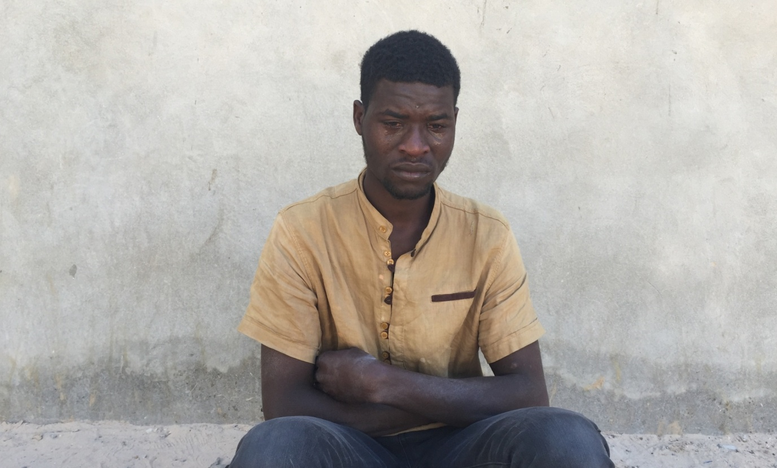
Mohamed Abdallah, 21 – Sudan

Mohamed Abdallah is from Darfur, in Sudan. Since 2003 there has been an as-yet unresolved conflict there, killing tens to hundreds of thousands of civilians through the killings, starvation and disease. Over 2 million people have been displaced because of the conflict.
Mohamed left for what is now South Sudan in 2006 after his village was destroyed, his father died and his sisters were raped. In South Sudan, war also broke out. He travelled north, through the Sahara - a journey that killed his brother and cousin - to Libya. There he witnessed his third civil war in a decade.
“There is a war in my country, there’s no security, no equality, no freedom. But if I stay here, it’s just like my country. There is no security, there is violence. When you work, they take your money.”
Mohamed worked in a soap shop, and saved up to pay local smugglers for the boat to Europe. But just as he hoped to complete the payment, he was robbed, and then arrested. He is currently being held in a migrant detention centre in Zawya, Libya.
“I need to go to Europe.

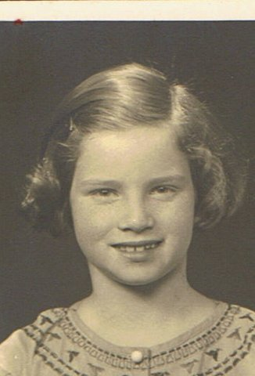
Ann Kirk - Berlin
My name at birth was Hannah Kuhn and I was born in Berlin to professional middle-class parents enjoying a good standard of life. However, after 1933 that all changed as Hitler’s antisemitic laws began to bite and my parents were desperately trying to emigrate, but all their attempts were unsuccessful.
By a sheer coincidence they were contacted by two Jewish unmarried sisters, voluntary workers in the East End, who were prepared to offer me a home and so, aged 10, I was registered with the Kindertransport. The date for my journey was 19th April, 1939 and I so well remember the hordes of crying parents and children at the Station. As they kissed me goodbye, they told me to look out of the window at the next station but one. This I did, and there they were waving frantically. That was the last time I ever saw them.
We travelled to Hamburg where we boarded an American ship, the Manhattan. The crew made a great fuss of us younger children, and the leaders tried to cheer us up with guitar-led communal singing. But it was not much use and there were a lot of tears. We arrived at Southampton two days later- our children’s passports were stamped with – Leave to land, granted provided that the holder does not enter gainful employment - and boarded a train destined for Waterloo Station. Jewish ladies handed us chocolates and biscuits with smiles – the first friendly smiles from strangers that we had seen in a long time.
My Kindertransport experience was really quite exceptional, since I knew to whom I was coming, and what is even more important my parents knew to whom I was going. By contrast, many Kindertransport children had no idea where they were going and they and their families faced great uncertainty as to their future.
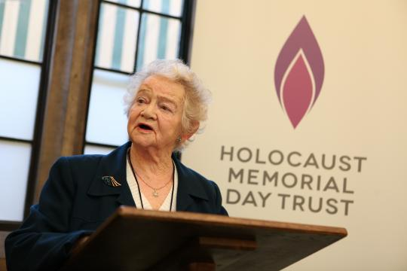
As a ten-year old, my feelings on my journey were a mixture of trepidation, but also excitement – a feeling that my parents had encouraged - allowing me to firmly believe that they would be joining me in the near future. That, of course sadly did not happen.

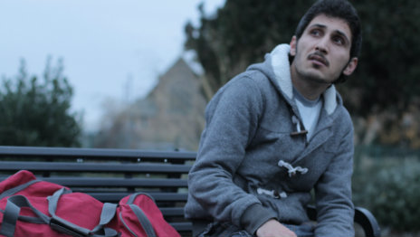
Dariush – Kurdish, from Iran
Dariush’s family are Kurdish, living in Iran. “My family were very political,” he says. “They were not supporters of Ahmadinejad’s regime. My father used to be a freedom fighter [when he was younger]. Then he came back to Iran to work”.
His family’s political affiliations brought much trouble on the family. ’When you don’t support them, they look for any small reason to cause you problems,” Dariush says. By the time he was sixteen, he’d been detained five times – sometimes for just a few weeks, but once for three months. “I was underage when I went to jail,” he says, “and the Head of the Prison instructed people to intimidate [me] and make [me] afraid”.
Disturbed by being in prison so young, Dariush self-harmed, and was sent to hospital. His father was told to pay a guarantee for his temporary release. Rather than see him returned to prison, his family sent him to stay with an uncle in Iraq after paying for his release – forfeiting the money.
“I thought I was just going for a visit,” says Dariush. But his family were afraid – and decided he would be better off seeking protection in Europe than hiding out in Iran or Iraq, being so young and a victim of persecution. “My father called me,” says Dariush, “and said don’t come back”. Hearing those words devastated Dariush. He never saw his family again.
Dariush’s uncle paid a group of smugglers to bring him to Europe in a goods lorry, eventually arriving in the UK. “It was horrible’ he recalls. ‘It took a week and I only left the lorry twice - there were five of us [in it]. I can’t forget it, even after five years. It was such a difficult experience”.

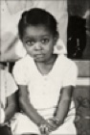
(Baroness) Floella Benjamin OBE – Trinidad and Tobago

I was born on the Caribbean island of Trinidad, in a small town called Pointe-a-Pierre on the 23rd September 1949. My first memory of that wonderful sun drenched Caribbean island was when I was three years old and I treasure those memories. With my three brothers and two sisters I grew up as part of a family rich in culture, love, happiness and freedom.
Aged 3
When my parents announced that they were leaving for England, our lives were turned upside down. We were left in the care of family friends, who we had to cal Auntie and Uncle as a sign of respect, while our parents went to England. The idea was that they would send for us as soon as they had secured work and accommodation.
This was the most unhappy time of my life. I found myself living with a family of strangers who treated me like a servant, expected to do all the dirty and menial tasks whilst the money my parents sent each month was kept by our unscrupulous 'aunt'.
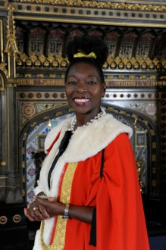
Finally the glorious news arrived that our parents are sending for us. In 1960 we made the two week journey to England, unaccompanied by adults on a passenger ship, across the Atlantic Ocean. Dressed in thin clothing, best suited for the Caribbean climate, we embarked on the long sea trip, enjoying our new found freedom and making friends with the sailors who encourage us to help with work below decks.
Gradually the seas turned from blue to grey, the temperature fell and, for the first time in my life, I felt the damp chilly hand of the British climate grip my heart and soul. As the ship docked at Southampton however, we were united as a family once again and I was warmed by the sight of my beloved mother who was waiting with embroidered cardigans and jumpers for my siblings and me.

Jamal Osman – Somalia
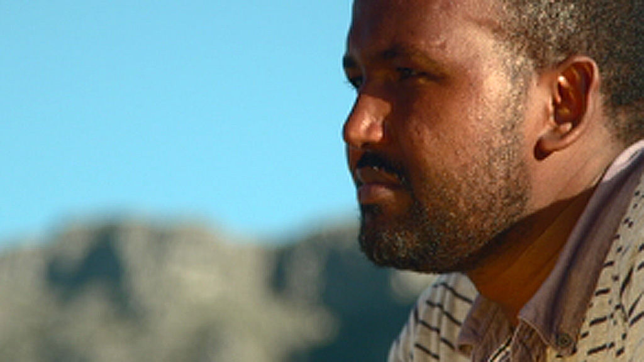
It was in 1996. I was a teenager. At that point, the Somalia war had been raging for several years. Fleeing from one place to another and going back and forth was the norm. By then, I had been to most of the neighbouring countries. But this time, my plan was to go as far as I could and away from the conflict. Destination: South Africa.
At a Kenyan border town, I boarded a bus to Nairobi. Most of the passengers were Somalis. So I was in some sort of a familiar zone - yet I was on my own. A few days prior to that, I had said goodbye to my family. They had to reluctantly accept my decision. It was made out of desperation, a necessity and a desire for a better life.
I was fleeing the Somalia war, which since then has taken many twists and turns and is still going on. It has caused death and destruction to millions of innocent people. I happened to be one of those affected by the conflict, one of many confused by what was going on.
My trip to South Africa was one of several journeys I made within Somalia and to neighbouring countries in a ten-year period before I ended up in London. Other countries I sought refuge in were undoubtedly safer than Somalia, but I never felt entirely comfortable living in a foreign land. There are aspects of life that you will not experience anywhere else. The deep relationship between a human and their home country is irreplaceable. It is the familiar scenery, the unpolluted air and the surrounding sound.
Each time I had to leave home, I would feel homesick and then go back to it, hoping the situation would improve. Even after surviving a massacre, I was not convinced to give up life in Somalia. In the early years, life in a foreign land was not a desirable option. It took me about a decade to decide that there was no future in Somalia.
Not many migrants decide overnight to just walk away from everything they have known since birth. No-one wants to face the uncertainty that lies ahead. No-one wants to risk life itself, in the hope of a better life. It takes a long time to come to that decision, and even when you decide, you don't just board a flight to Europe or America.
To reach somewhere desirable, it takes years of trying, travelling thousands of miles and risking it all. That's what I did...

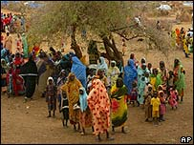
Fayza Ahmad – Darfur, Sudan
After being arrested and tortured three times by the government and after her journalist husband was arrested and then disappeared - she decided to leave Sudan with her children.
She embarked on a journey that would take two years.
I fled from Khartoum to the west of Sudan, with my three children.
From there we went to Chad, and after that, Syria.
I didn't have a passport at that time, and I had to buy a false one.
We asked someone to help us travel to Ukraine, because in Ukraine you need a visa at the airport. But the man escaped with our ticket, our money, and our passports.
We spent five months in Syria waiting in turn to find a passport. But unfortunately, Ukraine did not allow us to enter, and we had to go back to Syria again.
We tried again, travelling to Ukraine, and this time got in. But, as black people, we were treated very badly.
We asked all the people we saw to help us to get to any safe country. Eventually, we were helped to get to Moldova.
Part of this meant I walked for five hours to cross the borders.
When I got to Moldova, a Sudanese there helped us, and that is how I ended up in Britain.
I cried so much - for those two years between leaving Sudan and entering Britain, my children had no schooling at all.
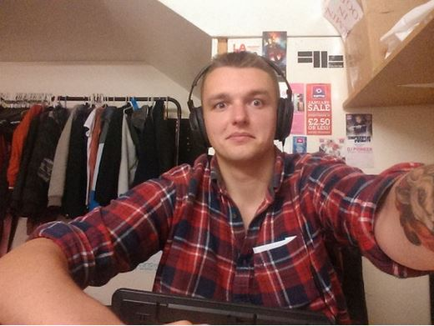
Bartek Rusinowski – Poland
For me, London is a capital city of entertainment and music – my hobby and job. I had my own company in Poland, but I had too many problems with expensive taxes. My last contractor was the local council. It was full of mafia. They didn't pay the full amount of money for the invoice of my small company. I had to take a huge loan to pay for salaries for my staff (20 people) and other costs. After that, I decided to move and start my life in the modern world – the UK.
I came to the UK in November 2013, alone and without money. I started to work at an Amazon warehouse and lived in Luton for two months. I had to change my room six times because all the houses were dirty and in unsafe areas. It was a difficult period for me. I lost a job, a girlfriend and good humour. Then I started to work as a marketing/event manager in a nightclub in Ealing Broadway in January 2014. I am the main promoter of music events. I love this country, the lifestyle and that feeling that everyone is important, and even if you have basic salary you have money for almost everything every week!
The experience has been positive. I started a totally new life, interesting job. I would like to stay in London. It is a perfect city for me. Modern, with a long list of opportunities to work, to have fun etc. The tax system is clear, members of all services – police, public transport, council etc – are friendly and helpful. It's a total inversion of the Polish system. However, accommodation in London is too expensive.
Life is fine. I live in a nice area, my job is my main hobby. I would like to buy a house some day.

Feedback

